搞混

Confused

在這個專案中，你會學到機器學習可能會如何犯錯

In this project you will learn about how machine learning can make mistakes.

你會訓練一個辨別檸檬和葡萄柚的機器學習模型

You’ll train a machine learning model to recognise lemons and grapefruits.

一開始，你會先進行效果很差的訓練，故意讓電腦把兩種水果搞混

To start with, you’ll train it badly so that it confuses the two.

當你理解為何會發生這種情況時，你會重新訓練電腦，讓搞混的機會得以下降

When you understand why that happened, you’ll train it again so that it is harder to confuse.

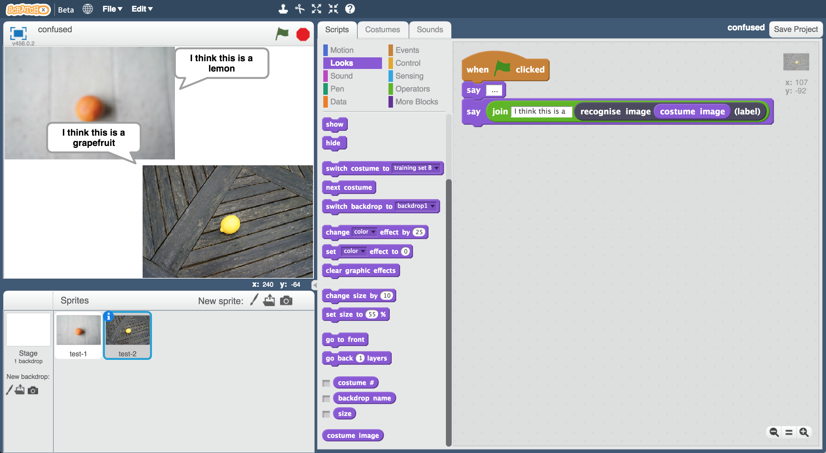

This project worksheet is licensed under a Creative Commons Attribution Non-Commercial Share-Alike License

http://creativecommons.org/licenses/by-nc-sa/4.0/

1. 搜尋網頁：<https://machinelearningforkids.co.uk/>

Go to <https://machinelearningforkids.co.uk/> in a web browser

1. 點選“**Log In**” 按鈕並登入系統

如果你沒有帳號，請你的老師幫你建立一個帳號。

如果你不記得你的帳號或密碼，請你的老師幫你重新設定一次。

Click on “**Log In**” and type in your username and password  
*If you don’t have a username, ask your teacher to create one for you.  
If you can’t remember password, ask your teacher to reset it for you.*

1. 點選上方清單中的 **”Projects”** 按鈕

Click on “**Projects**” on the top menu bar

1. 點選**“+ Add a new project**”按鈕

Click the **“+ Add a new project**” button.

1. 將你的專案命名為 “Confused”並設定成辨識 “**images**”類別，點選 “**Create**”按鈕

Name your project “confused”. Set it to learn how to recognise “**images**”. Click the “**Create**” button  
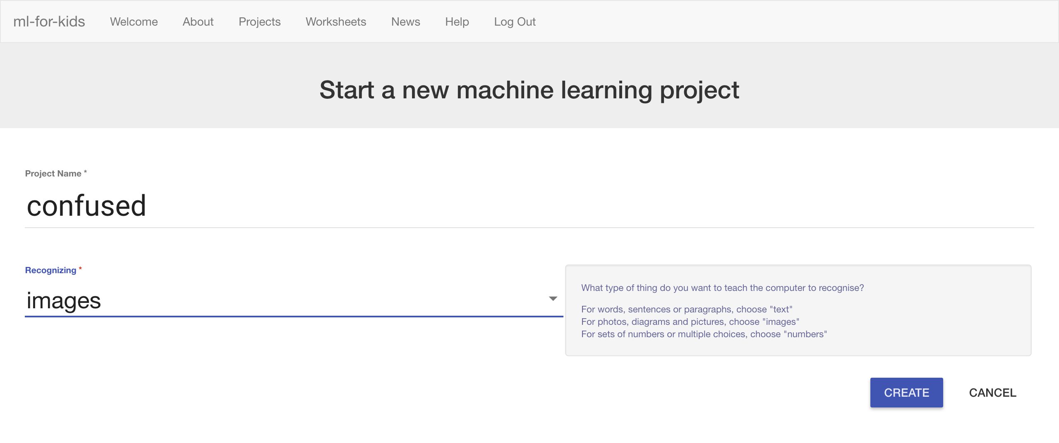

1. 你會在專案清單中看到“**confused**”，點選此專案

You should see “**confused**” in the list of your projects. Click on it.

1. 點選**”Train” 按鈕**

Click the **Train** button.  
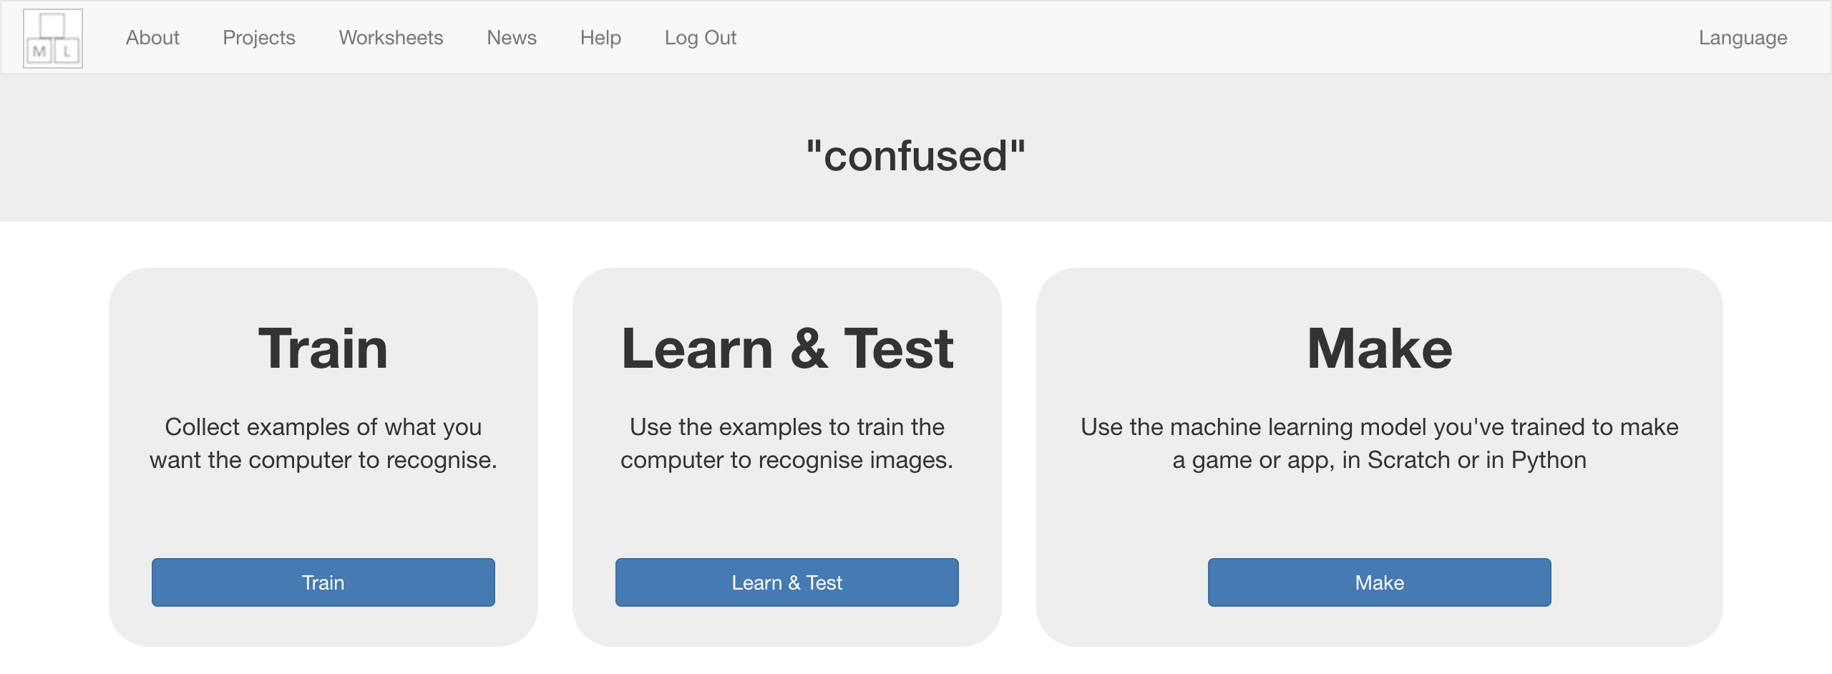

1. 點選**” + Add new label” 按鈕**

Click the **“+ Add new label**” button.

1. 新增一個叫作“grapefruit”的標籤(label)

Create a new label called “grapefruit”  
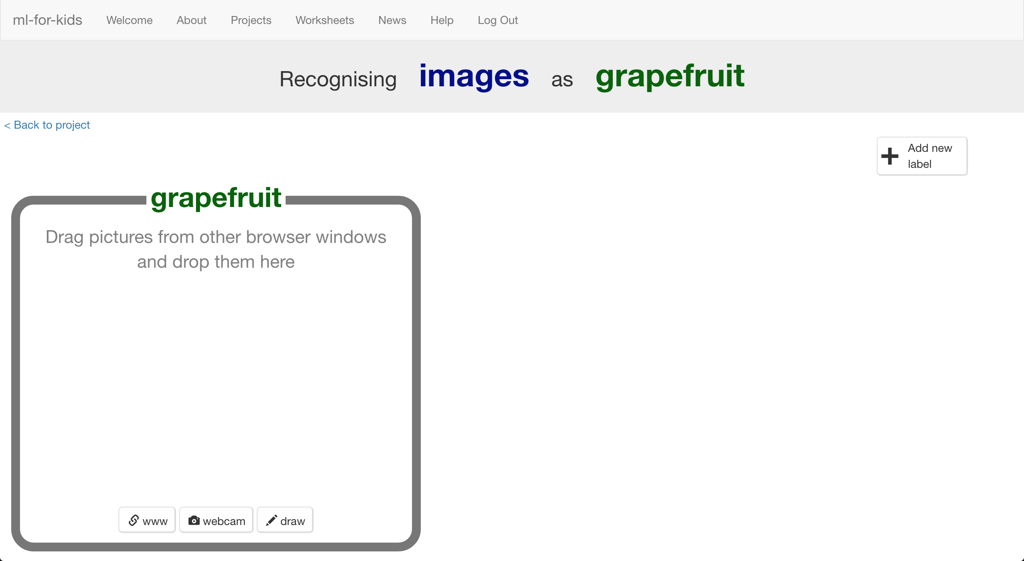

1. 再次點選“**+ Add new label**”按鈕並新增一個叫作”lemon”的標籤

Click “**+ Add new label**” again and create a label called “lemon”  
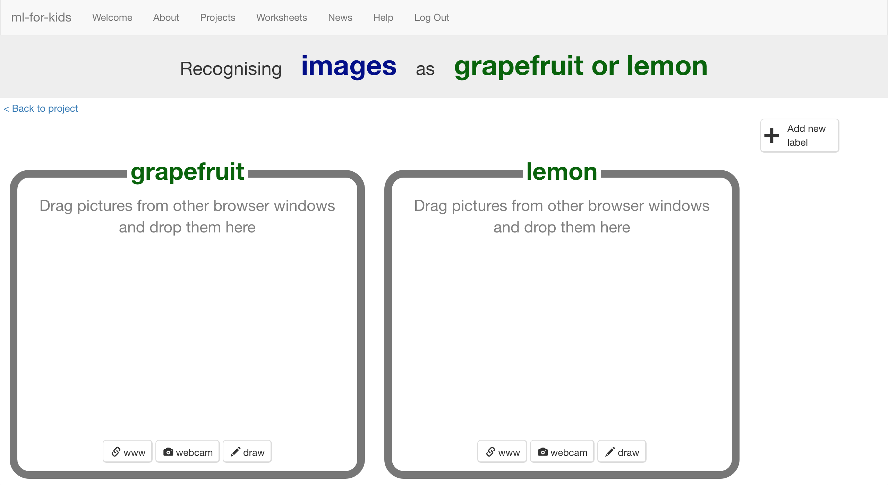

1. 開啟一個新的網頁

Open a new browser window  
*How to do this will depend on what web browser you’re using, but it’s probably going to be a menu like “****File*** *->* ***New Window****”*

1. 在新的網頁搜尋<https://machinelearningforkids.co.uk/datasets>

Go to <https://machinelearningforkids.co.uk/datasets> **in the new window**.  
*此網址與剛剛的網址雷同，只在網址最後多了datasets*

*That’s the same web address as before, with “data” “sets” on the end.  
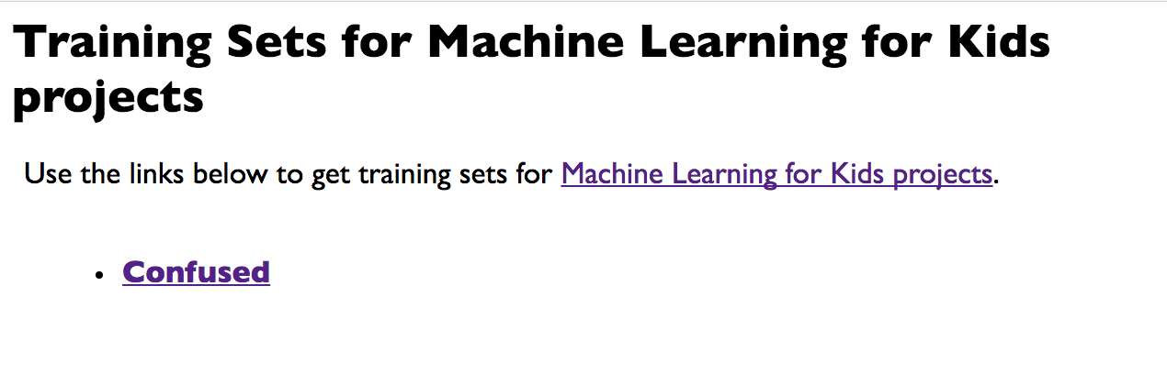*

1. 點選名為“**Confused**”的連結

Click on the “**Confused**” link

1. 點選“Training Set **A**” 或“Training Set **B**”

*從A和B中挑選一個，但不要選“Final Training Set”，那個之後會使用*

Choose “Training Set **A**” or “Training Set **B**” and click on it  
*You can use either.* ***Don’t*** *pick “Final Training Set”– you’ll use that later.*

1. 你會看到可以用來訓練電腦的葡萄柚與檸檬照片。

點選“Display thumbnails”，這樣才能看到所有的照片

You should see pictures of grapefruits and lemons that you can use to train the computer.   
Click on the “Display thumbnails” checkbox so you can see them all.

1. 調整兩個視窗大小（如下圖）

Arrange the two web browser windows so they’re side by side  
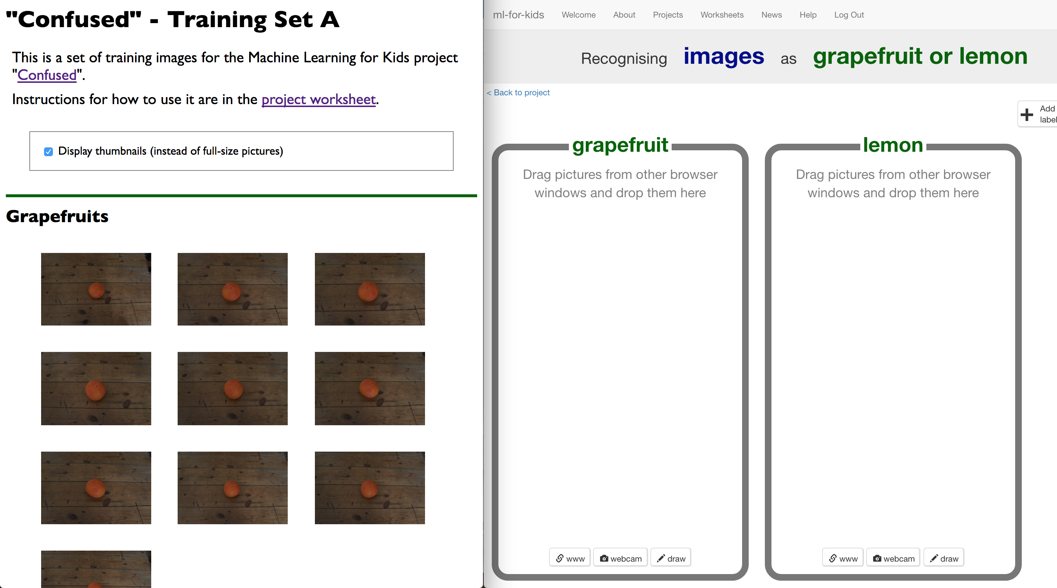

1. 將十張葡萄柚的照片拖曳至“grapefruit”的方框

Drag the ten grapefruit pictures into the “grapefruit” bucket.

1. 將十張檸檬的照片拖曳至“lemon”的方框

Drag the ten lemon pictures into the “lemon” bucket.  
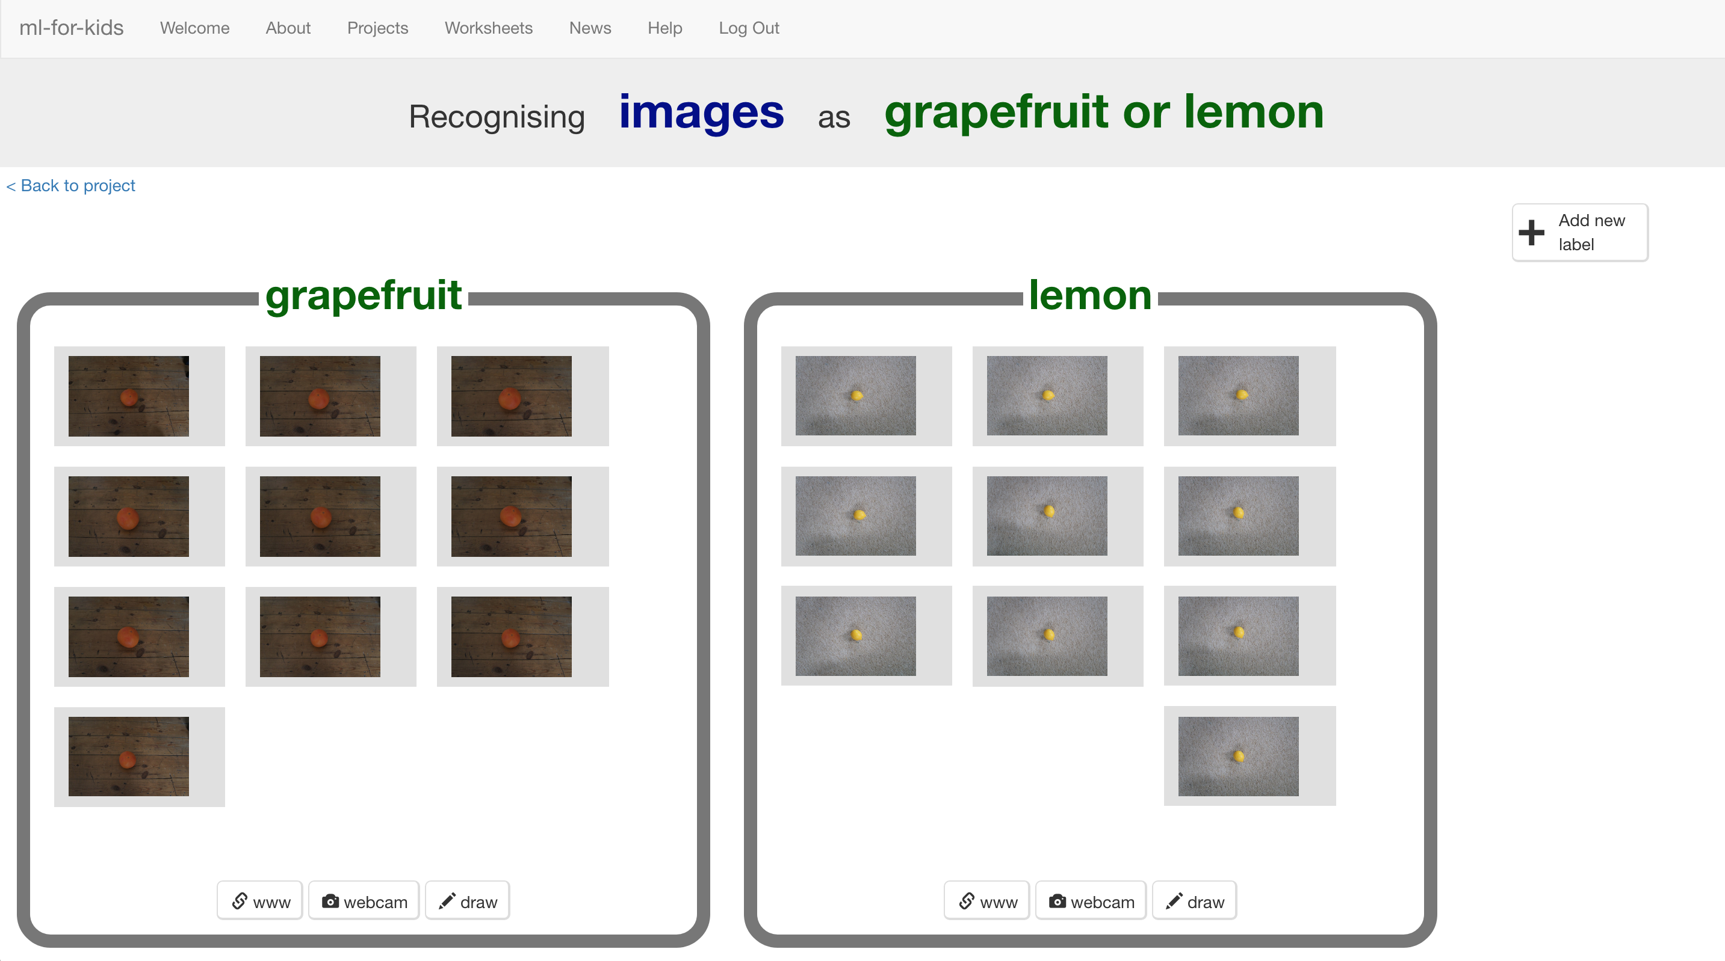

1. 點選“**< Back to project**”

Click the “**< Back to project**” link

1. 點選“**Learn & Test**”按鈕

Click the “**Learn & Test**” button

1. 點選“**Train new machine learning model**”按鈕

Click the “**Train new machine learning model**” button  
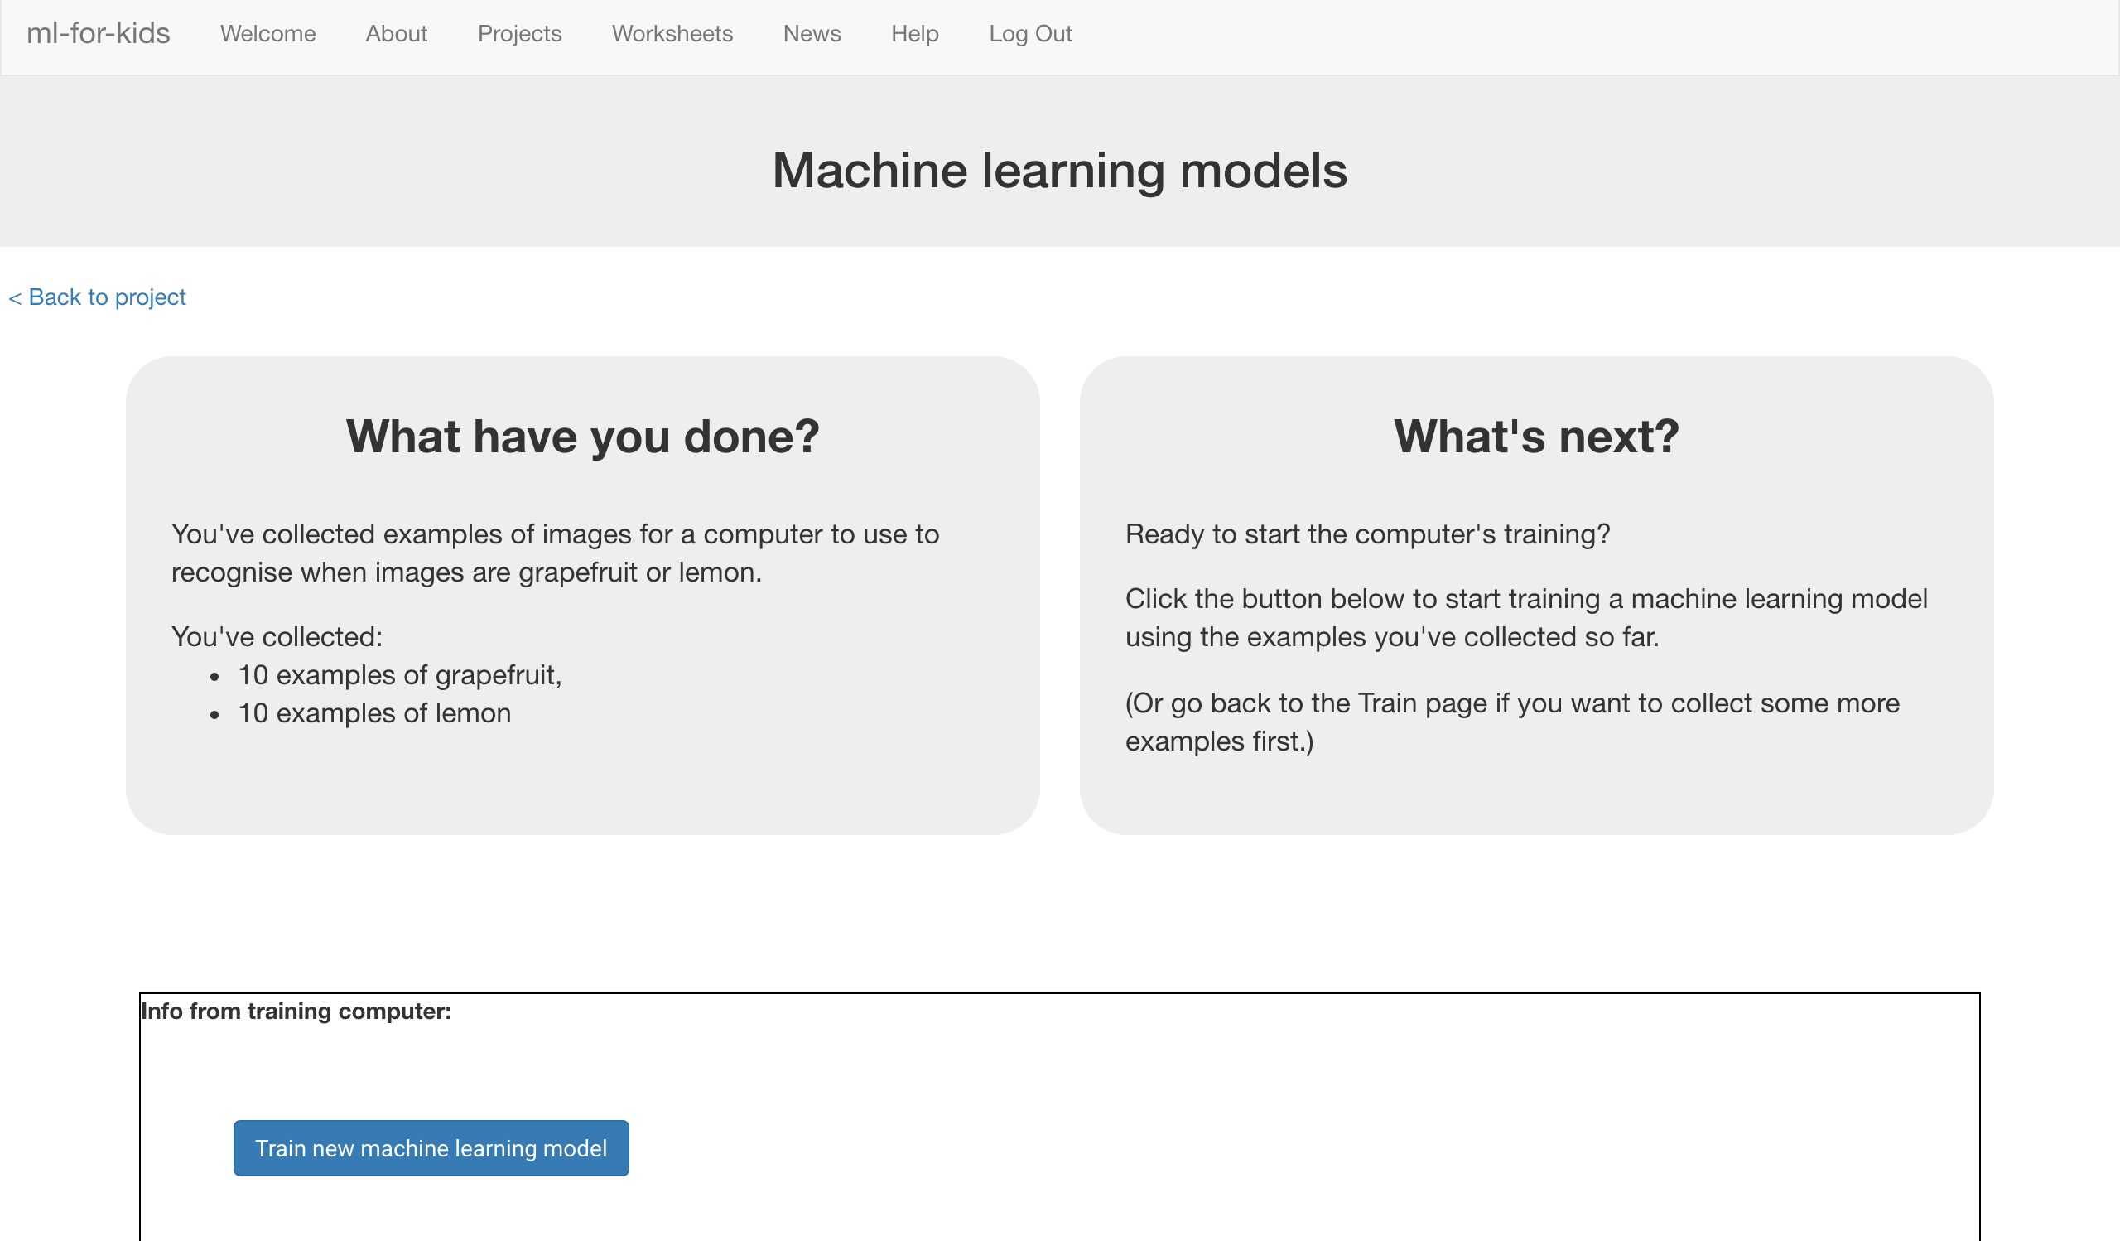

1. 等待訓練完成，這可能會需要幾分鐘的時間。

Wait for the training to complete. This might take a few minutes.

1. 點選**“< Back to project**”

Click the **“< Back to project**” link

1. 點選“**Make**”按鈕

Click the “**Make**” button

1. 點選“**Scratch**”按鈕

Click the “**Scratch**” button

1. 點選“**Open in Scratch**”按鈕

Click the “**Open in Scratch**” button   
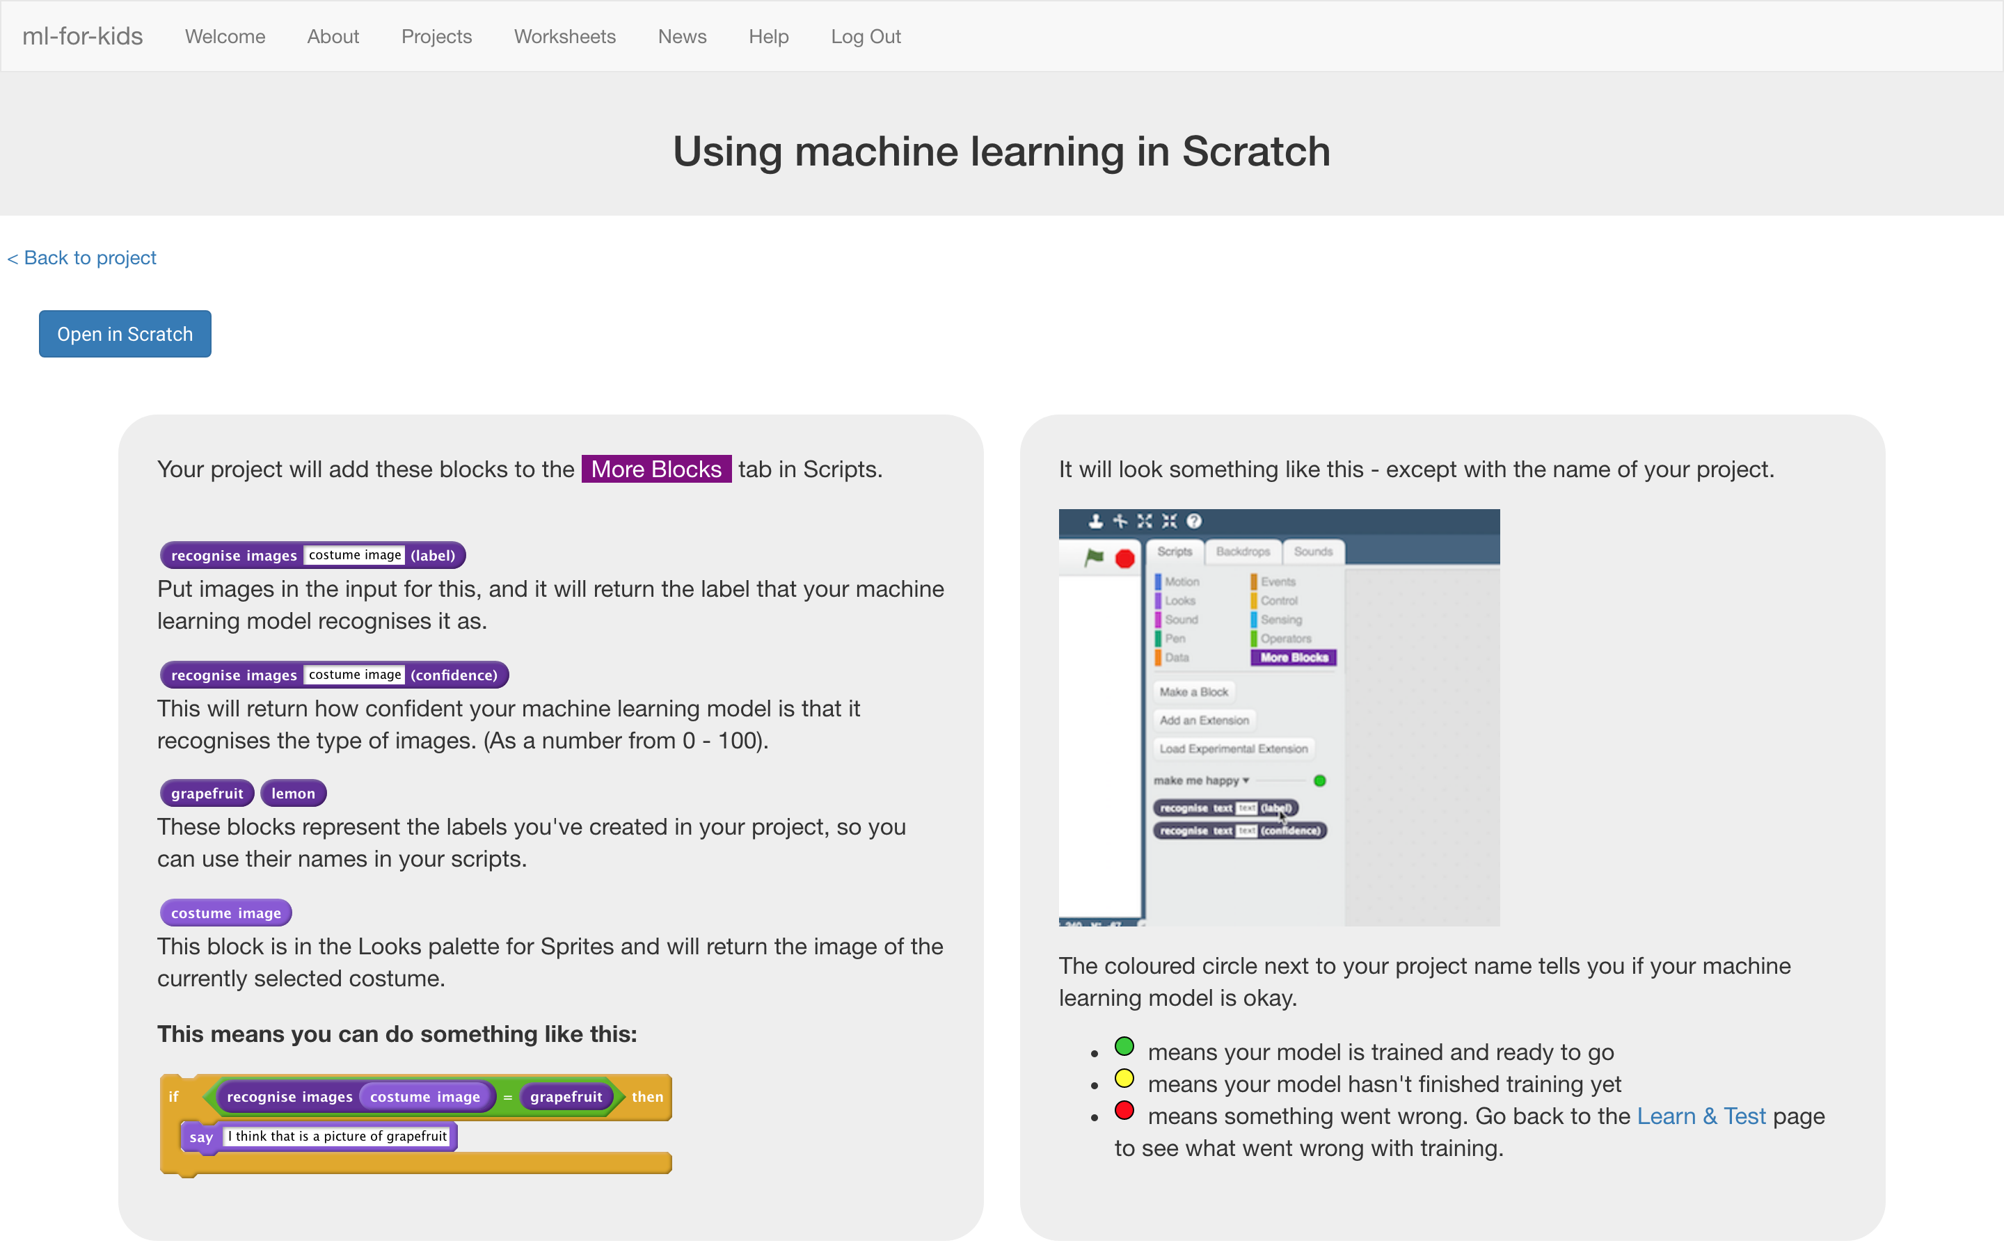

1. 你會在專案裡的『更多積木』(More blocks)區看到新積木

*You should see new blocks in “More blocks” from your project.*  
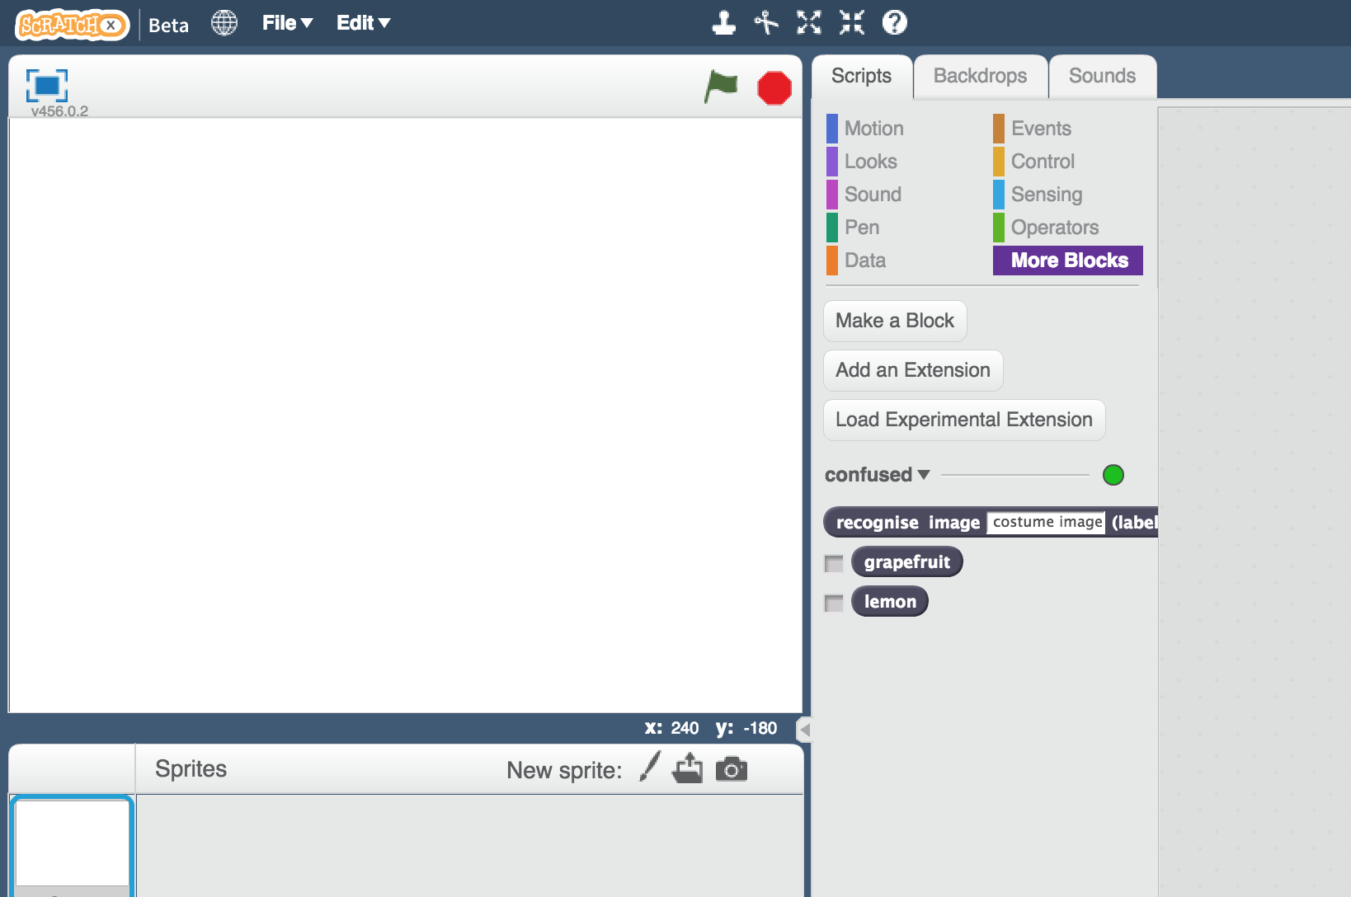

1. 開啟Confused專案

點選***Project templates，***再點選***Confused***

Open the Confused project template  
*Click “****Project templates****” -> “****Confused****”*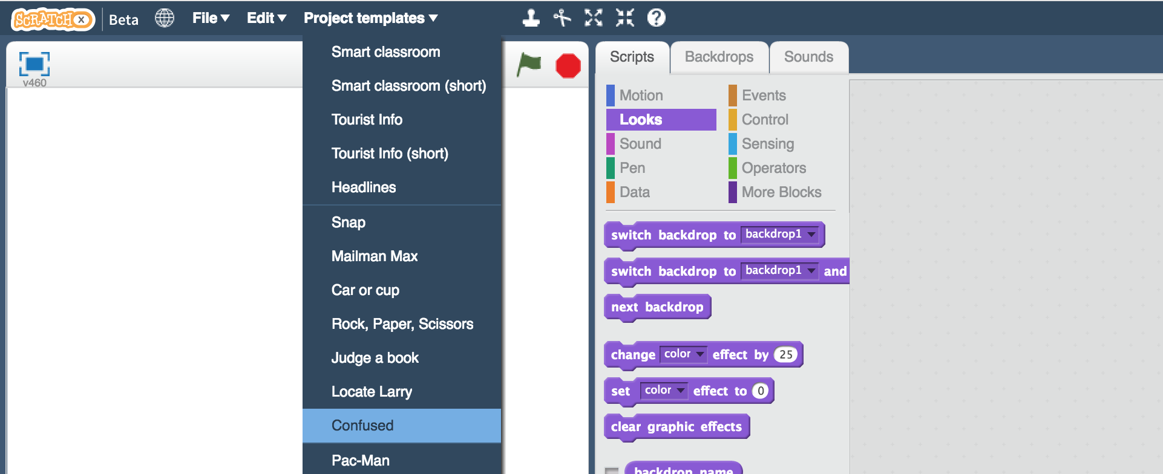

1. 點選名為“**test-1**”的角色

Click the “**test-1**” sprite   
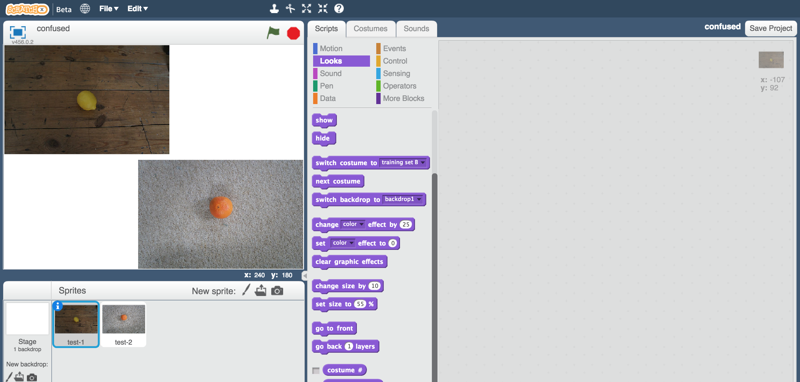

1. 拖曳積木至角色“**test-1**” （如下圖）

Create this script in the “**test-1**” sprite  
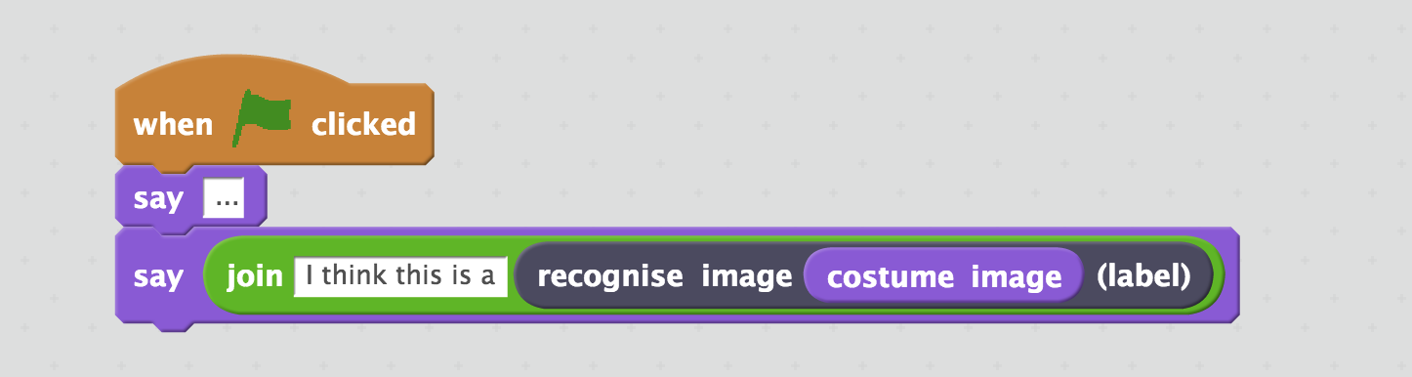

1. 點選『造型』

Click on the “**Costumes**” tab  
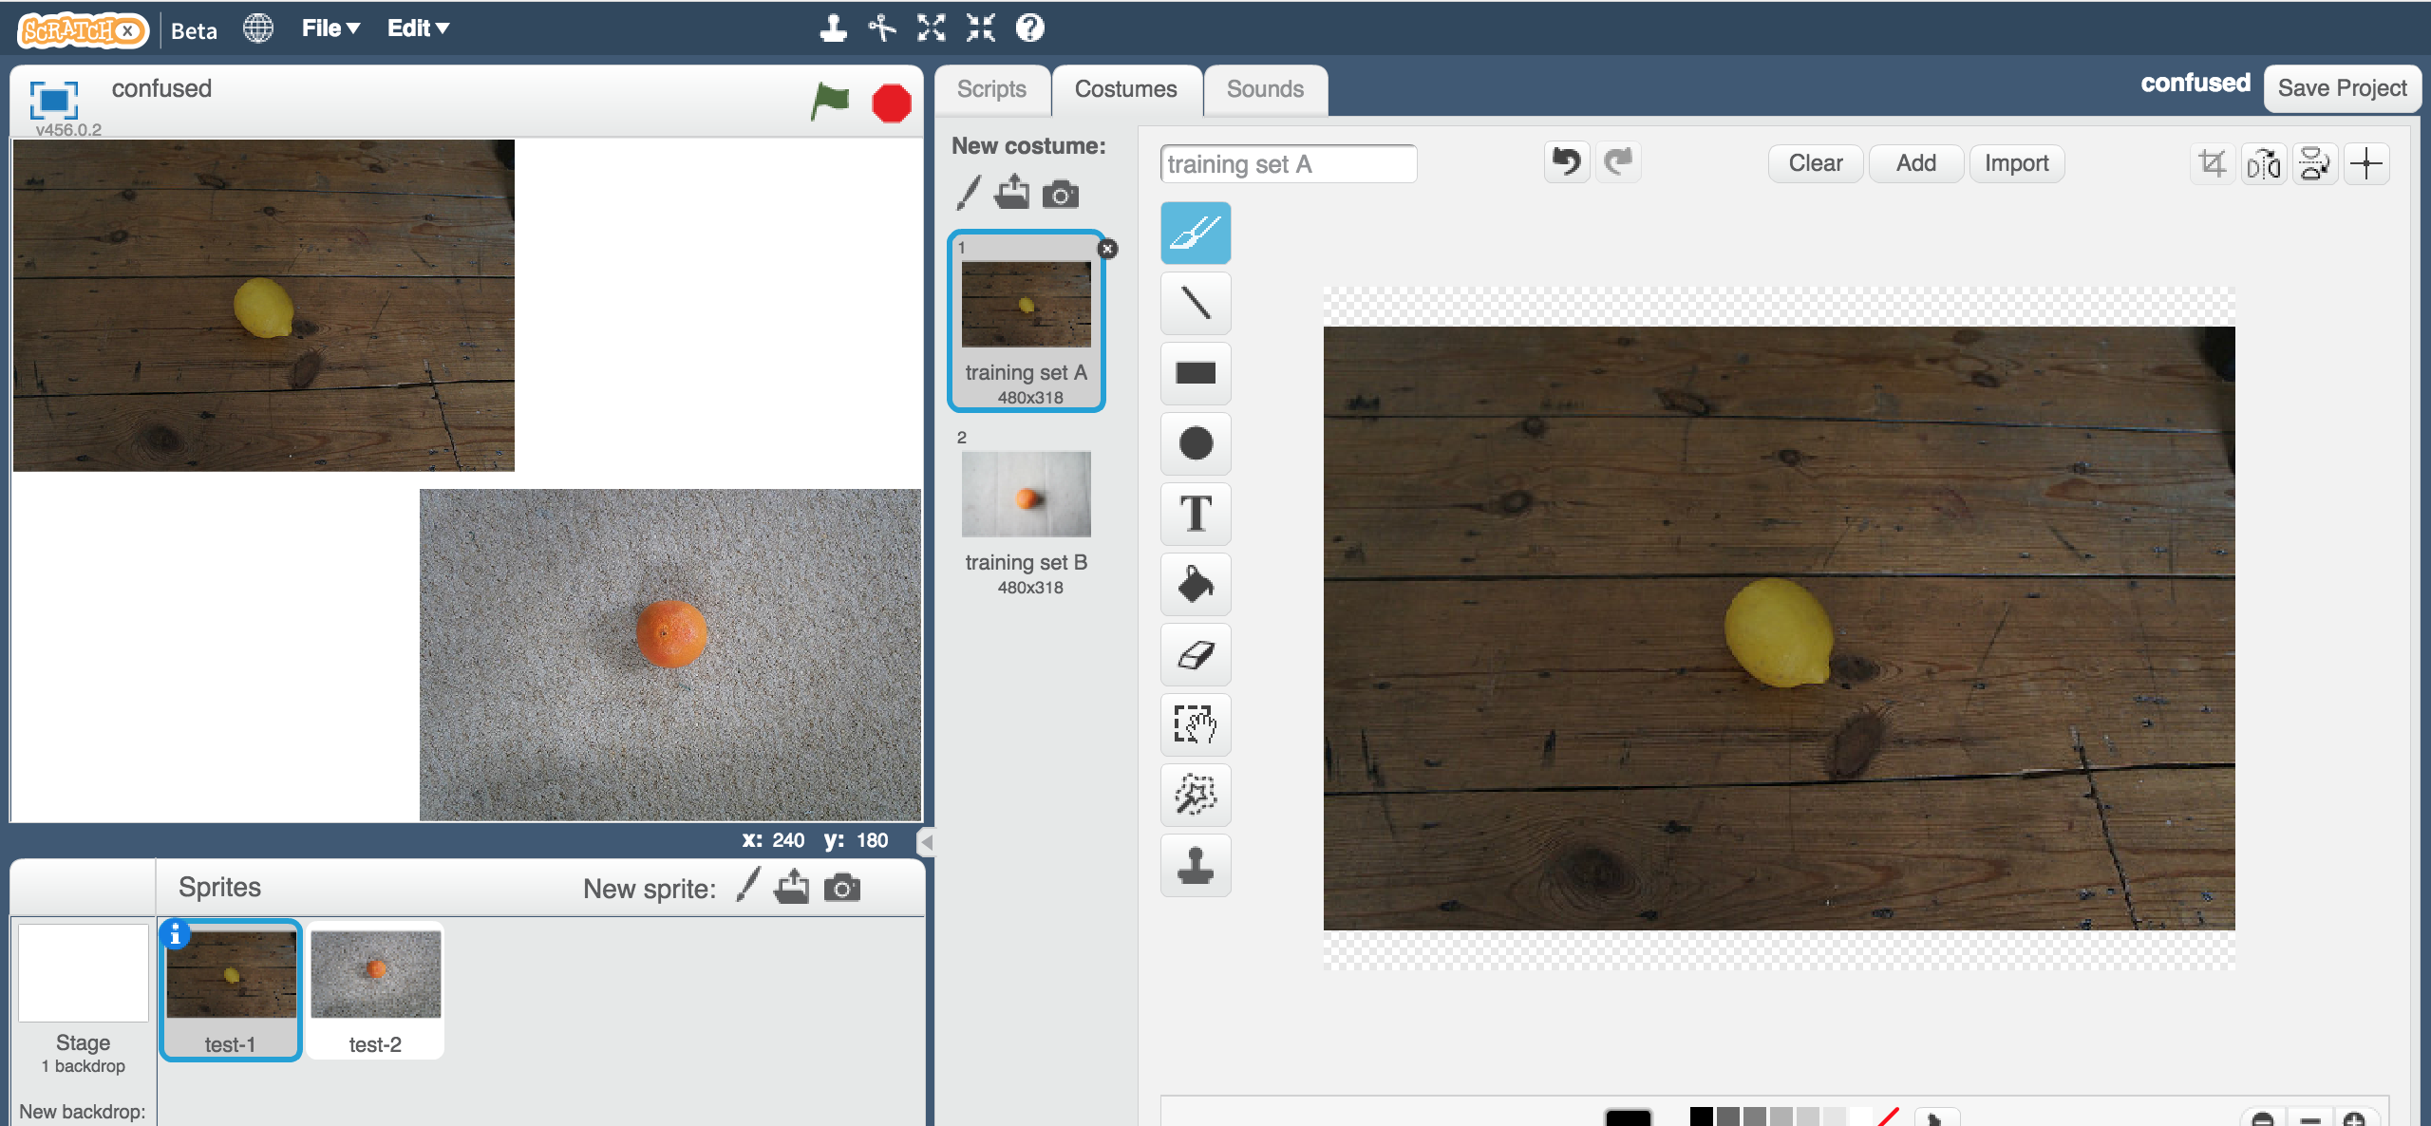

1. 如果你剛剛選擇的是“Training Set A”，就點擊名為“training set A”的造型。如果你選擇的是“Training Set B”，就點擊名為“training set B”的造型。

If you used “Training Set A”, then click the “training set A” costume  
**Or** if you used “Training Set B”, click the “training set B” costume instead  


1. 點選名為“**test-2**”的角色

Click on the “**test-2**” sprite  
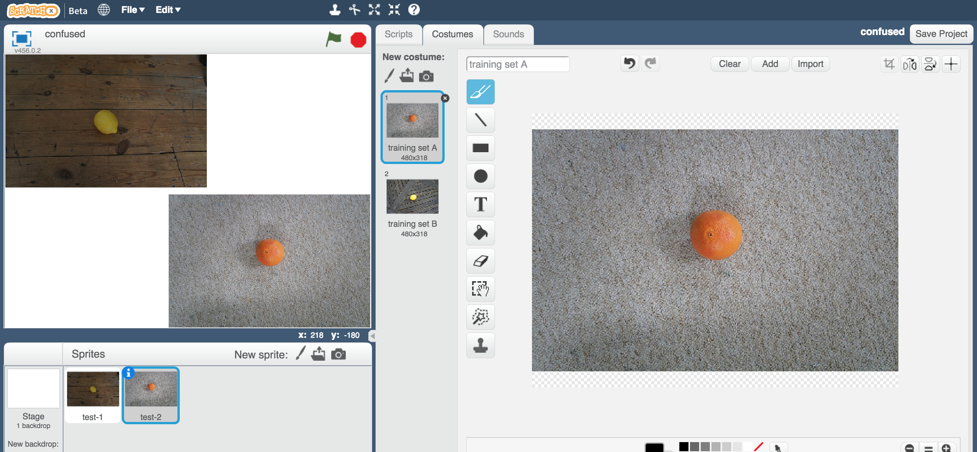

1. 如果你剛剛選擇的是“Training Set A”，就點擊名為“training set A”的造型。如果你選擇的是“Training Set B”，就點擊名為“training set B”的造型。

If you used “Training Set A”, then click the “training set A” costume  
**Or** if you used “Training Set B”, click the “training set B” costume instead  
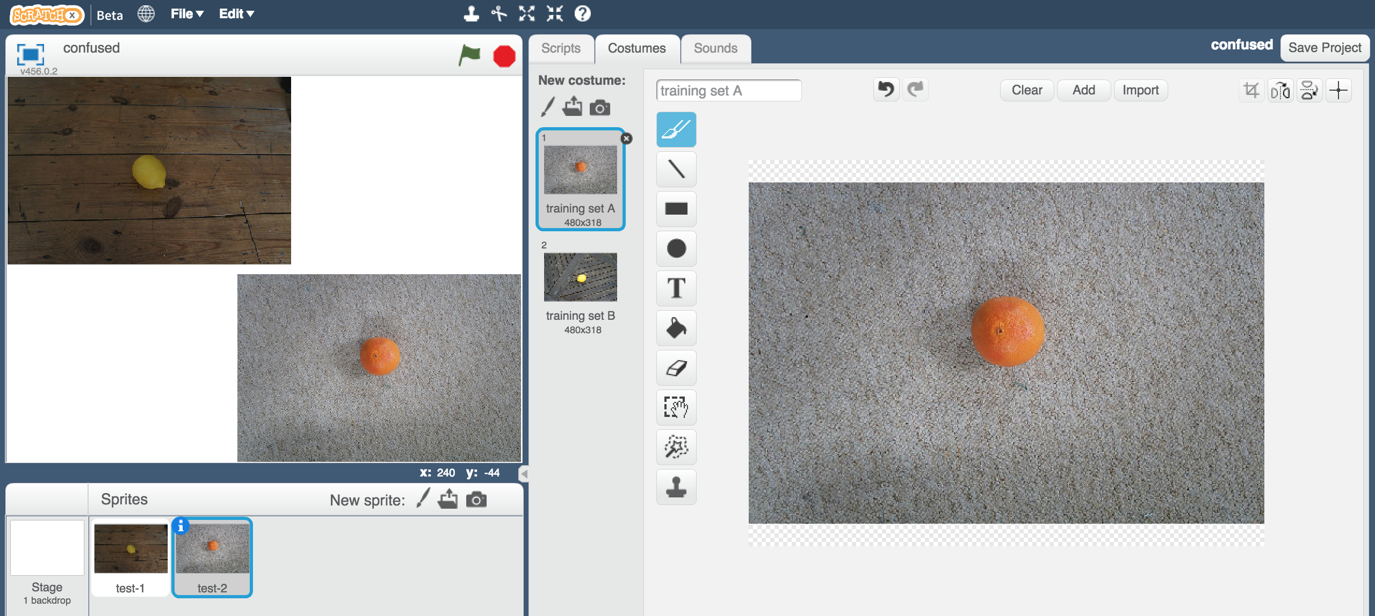

1. 點選『造型』 Click on the “**Scripts**” tab  
   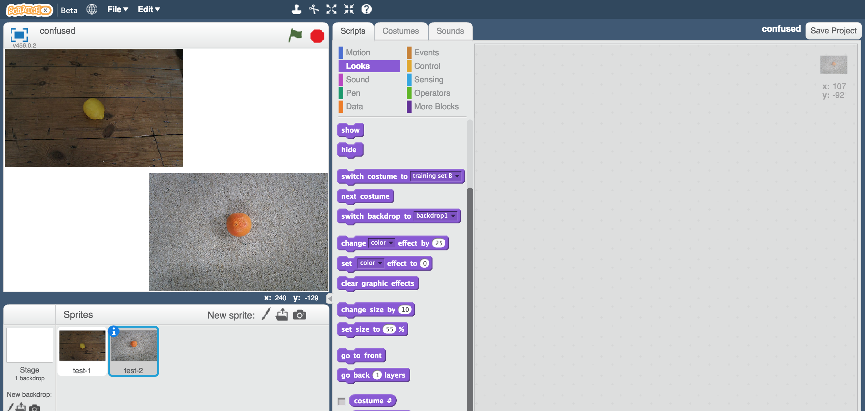

1. 拖曳和剛剛相同的積木至角色“**test-2**” （如下圖）

Enter the same script as before, this time in the “**test-2**” sprite  
*如果想節省時間，你可以直接把剛剛寫的積木拉至角色test-2放開，這樣就可以複製程式碼到test-2*

*You can save time by dragging the script you wrote before onto the test-2 sprite to make a copy of it.*

1. 點選全螢幕 Click the “**full-screen**” button  
   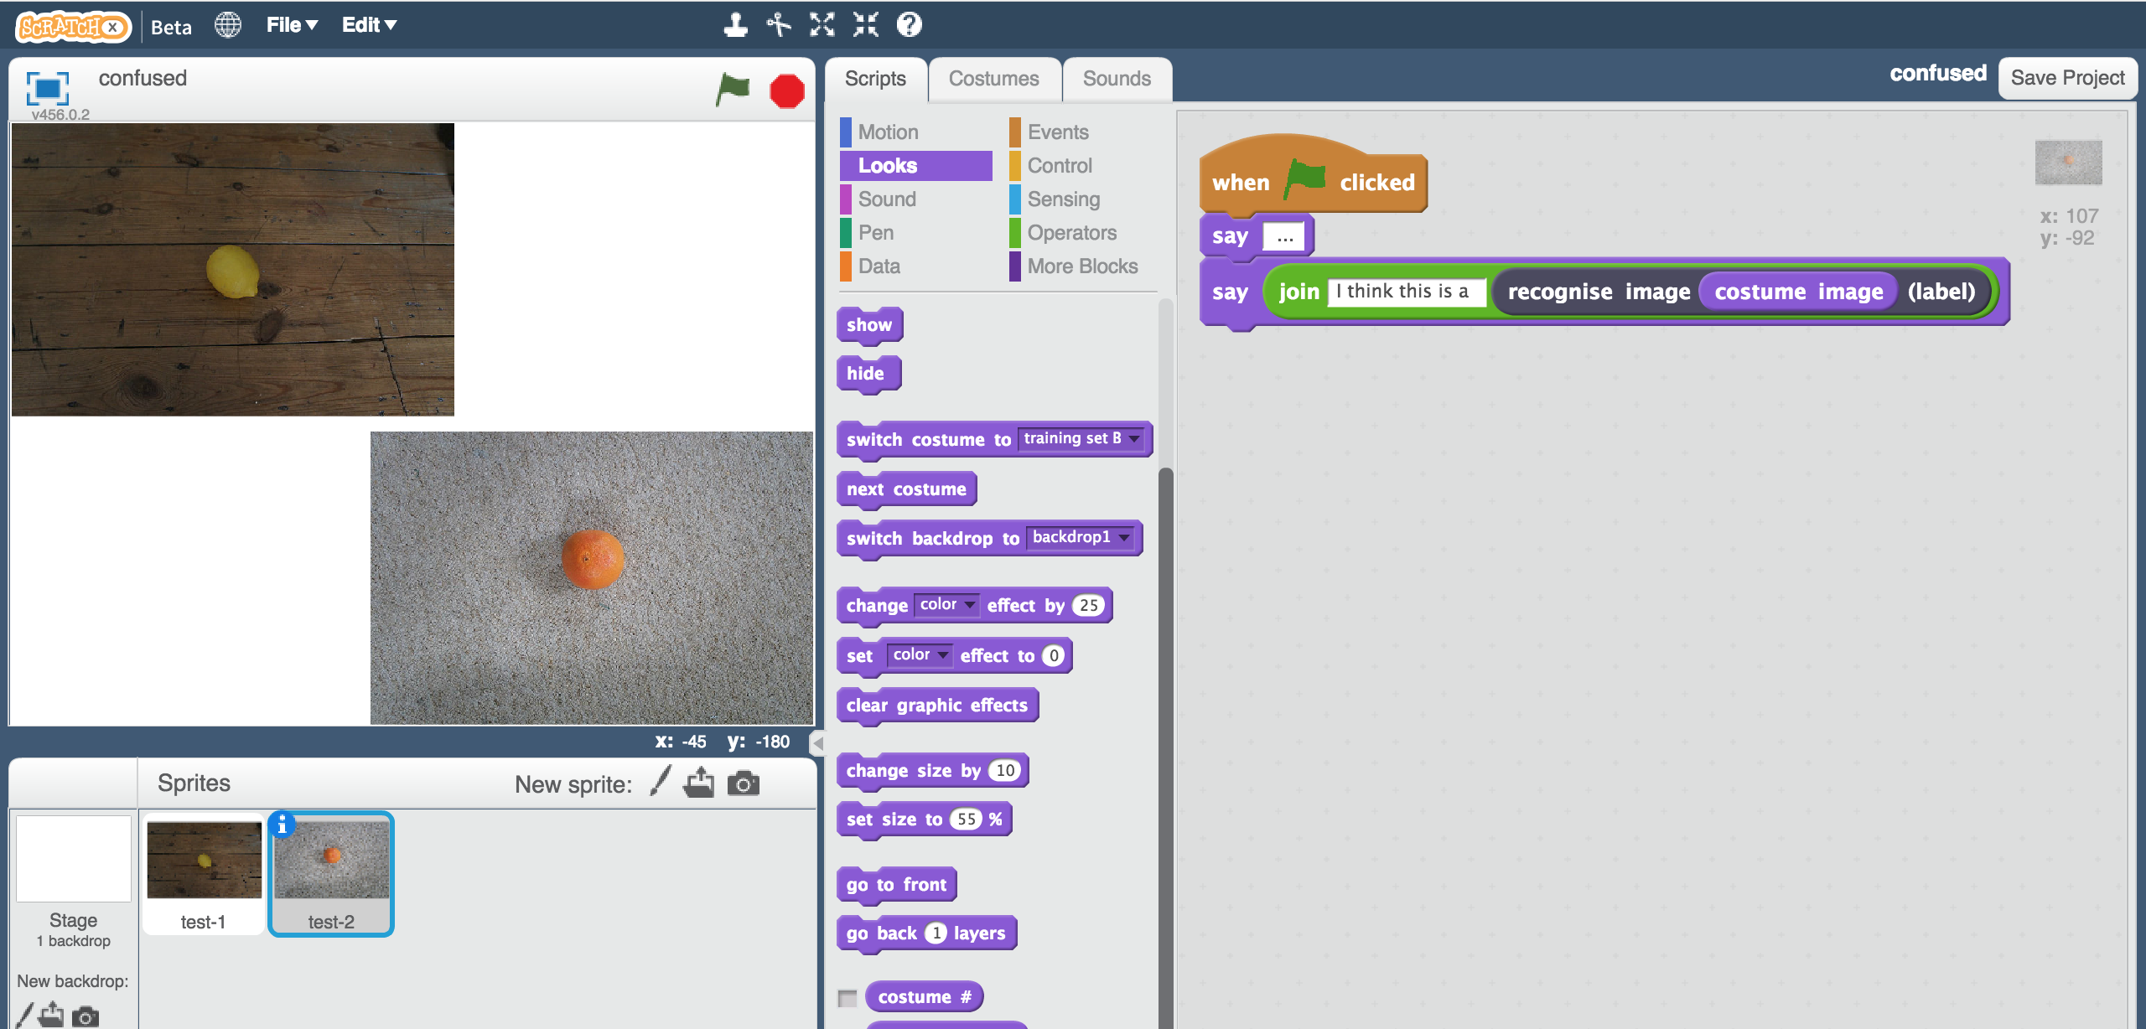
2. 點選綠旗

Click the green flag  
*你的角色會使用剛剛訓練的模型來辨識兩張圖片各別是什麼水果*

*Your script will use the machine learning model you trained to recognise the two photos.*   
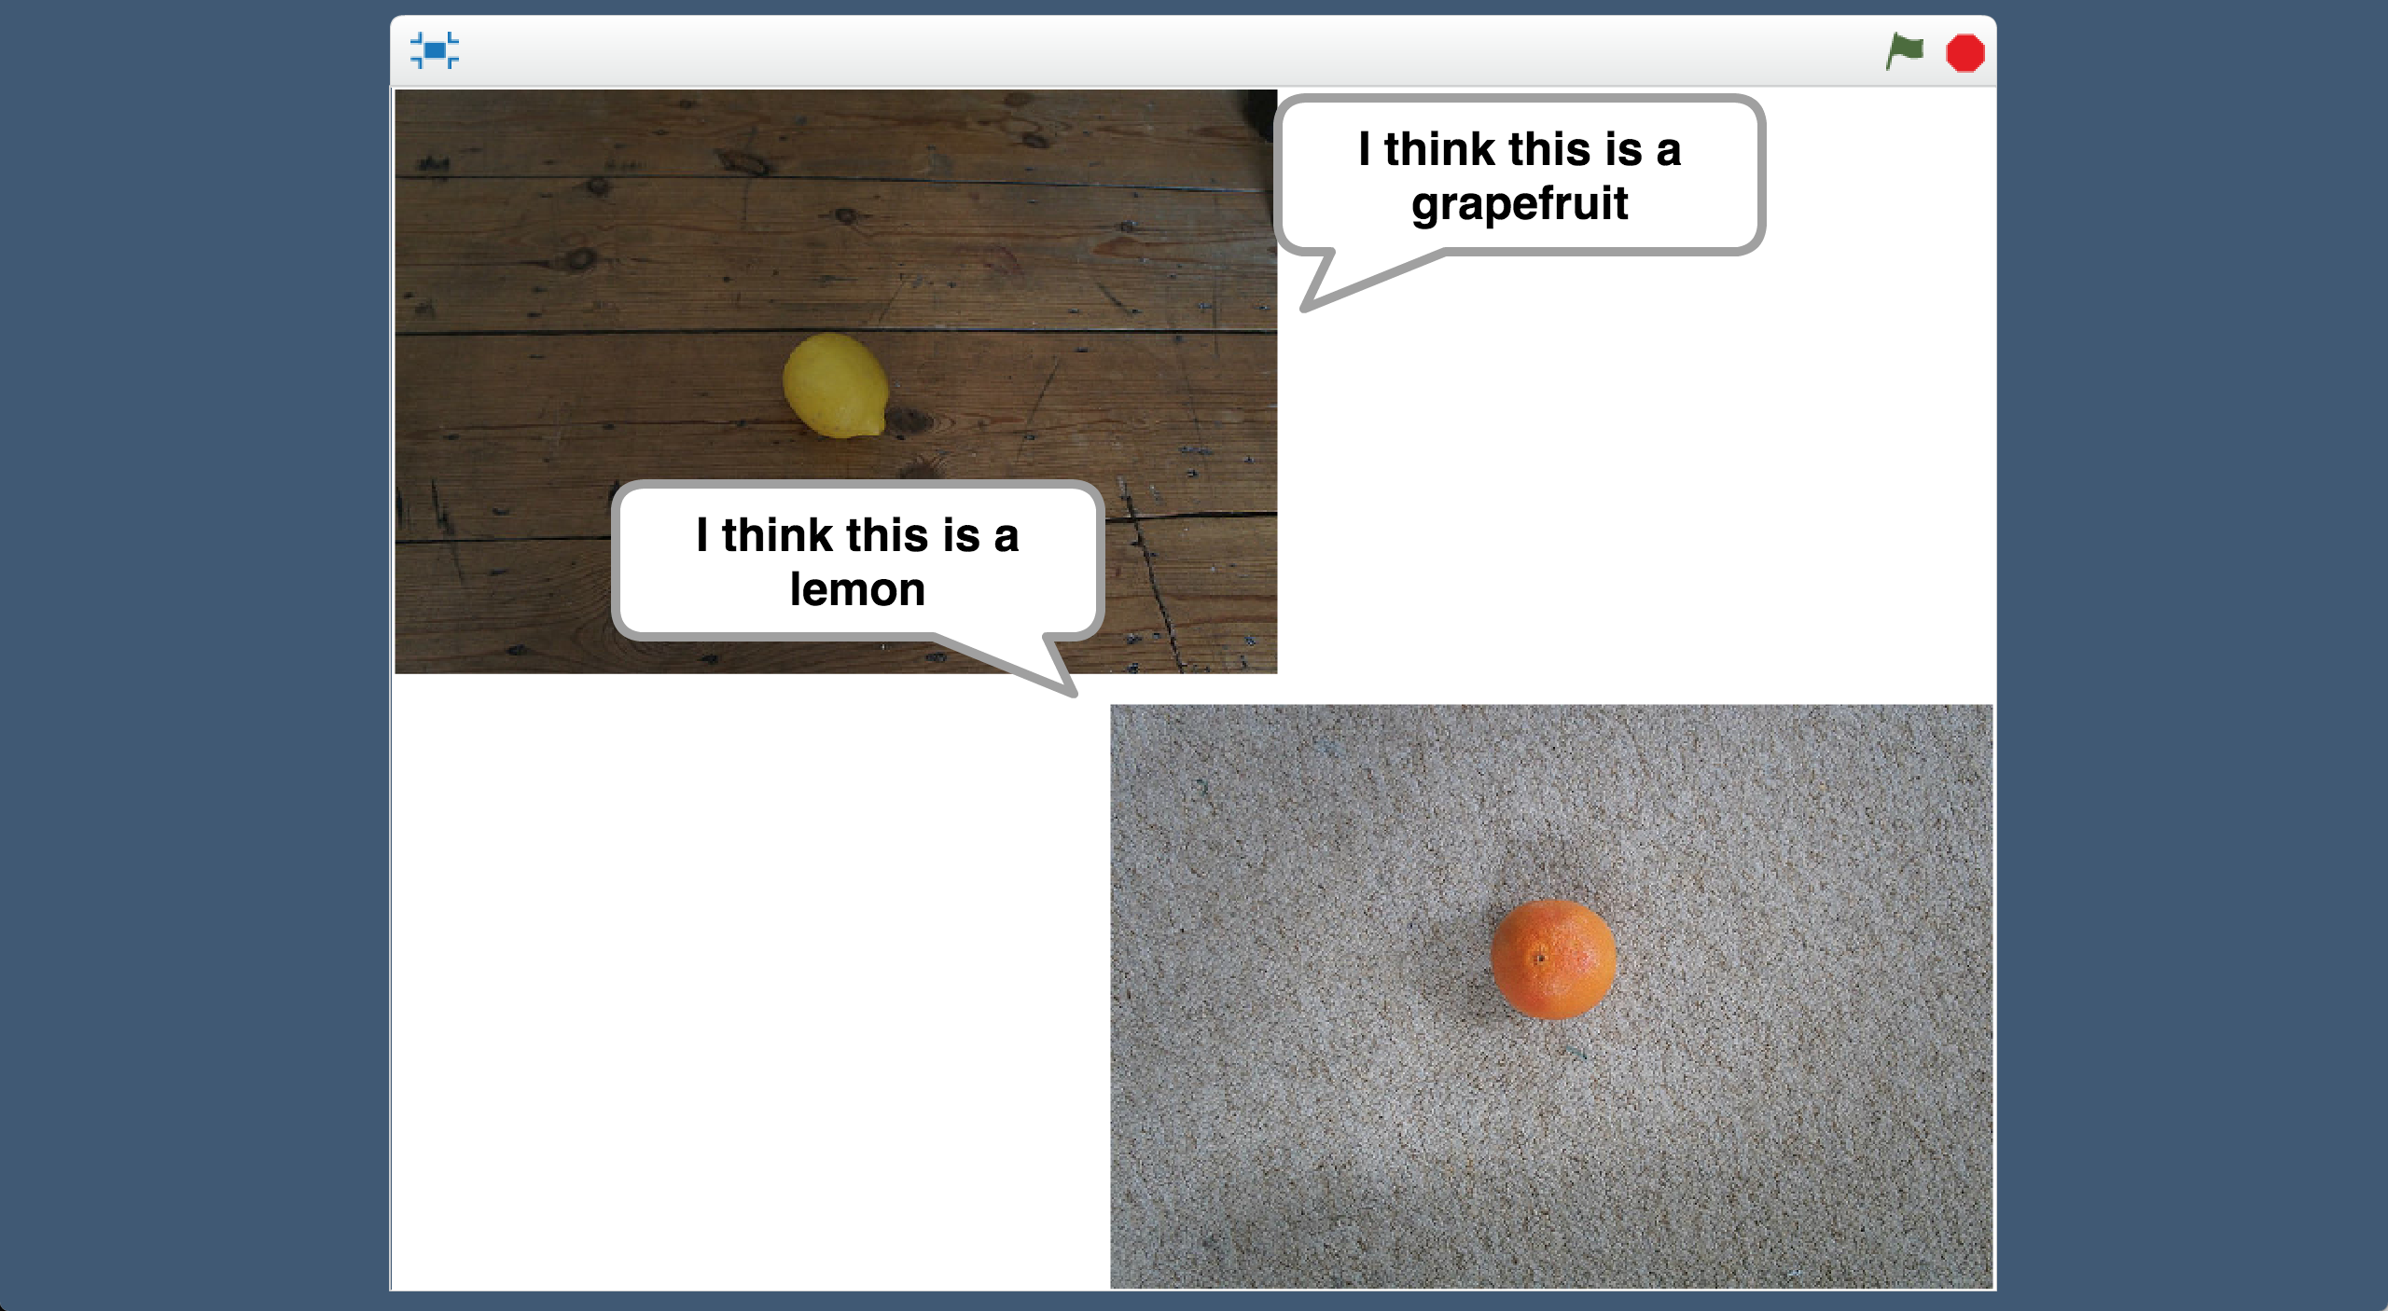

***你覺得為什麼電腦會出錯？***

***Why do you think the computer is getting this wrong?*** *翻到下一頁之前，試著想看看可能會是什麼原因讓電腦出錯*

*Try to think of a reason for yourself before you read the next page!  
 前面的訓練範本應該可以給你一點提醒，比較看看訓練用照片和Scratch專案中的測試照片有什麼不一樣  
 You might find it helpful to look back at the training set you used and compare it with the test images in the Scratch project.*

**發生什麼事了？**

**What is happening?**

當你在訓練一個機器學習模型時，你其實是在要求電腦從一堆照片中尋找共通的模式

When you train a machine learning model, you’re asking the computer to look at sets of photos for patterns.

電腦會在每堆照片中尋找他們的共通處，並學習檢查新照片中是否也有類似的地方

It looks for what photos in each set have in common, and learns to recognise those patterns in new photos it is given.

你可能希望電腦辨識水果，但是電腦並不知道。他可能會著重在背景顏色、照片是否模糊不清、燈光昏暗或明亮，或者其他東西上。

You might want it to have recognise fruits, but the computer doesn’t know that. It could spot patterns about the colour of the background, or whether the photo is blurry or focused, or whether the lighting is dark or bright, or many other things.

當電腦透過辨識這些共通點來辨別一張新的照片時，就有可能會出錯

When it makes decisions based on recognising those patterns in new photos, it can get the wrong answer.

**訓練資料 A**

**Training Set A**

『葡萄柚』- 一堆以**木頭**為背景的**昏暗**照片

『檸檬』- 一堆以**奶油色**地毯為背景的**明亮**照片

“grapefruits” – a set of **dark** images on a **wooden** background

“lemons” – a set of **light** images on a **cream** carpet background

使電腦混淆的測試照片：

Confused by testing with:

* 一張檸檬的照片，以**木頭**為背景且燈光**昏暗**
* 一張葡萄柚的照片，以**奶油色**地毯為背景且燈光**明亮**
* A **dark** photo of a lemon on a **wooden** background
* A **light** photo of a grapefruit on a **cream** carpet background

**訓練資料 B**

**Training Set B**

『葡萄柚』- 一堆以**木頭**為背景的**清晰**照片

『檸檬』- 一堆以**白色**地毯為背景的**模糊**照片

“grapefruits” – a set of **sharp** focused images on a **wood** background

“lemons” – a set of **blurry** images on a **white** rug background

使電腦混淆的測試照片：

Confused by testing with:

* 一張以白色地毯為背景的模糊葡萄柚照片
* 一張木頭為背景的清晰檸檬照片
* A **blurry** photo of a grapefruit on a **white** rug background
* A **sharp** focused photo of a lemon on a **wooden** background

1. 存檔

Save your Scratch project  
*點選檔案，再點選儲存專案*

*Click on “****File****” -> “****Save Project****”*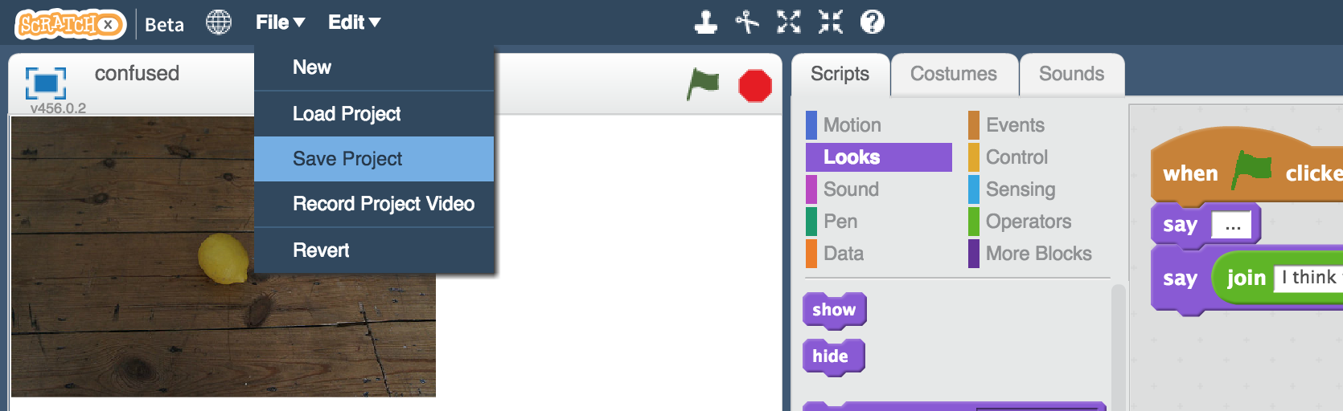

1. 回到訓練模型的網頁視窗

Switch back to the training tool window

1. 點選“**< Back to project**”，再點選“**Train**”按鈕

Click the “**< Back to project**” link and then click the “**Train**” button

1. 點選紅色叉叉，刪除先前的訓練照片

Click the red crosses to delete training pictures you used before  
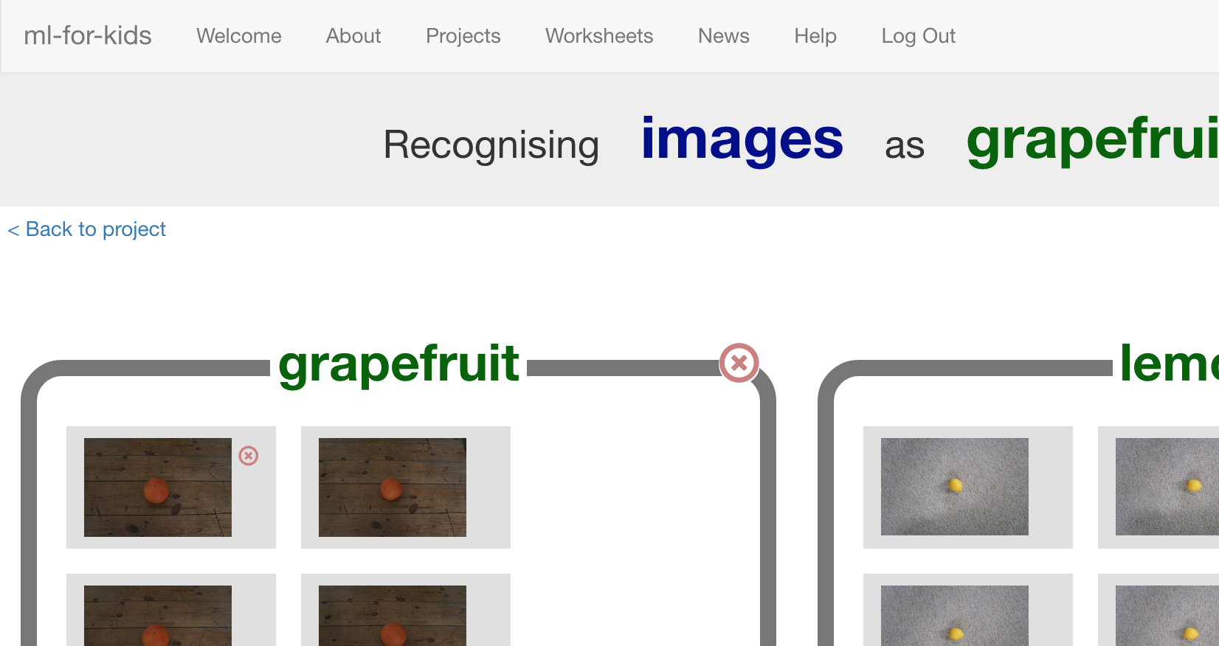

1. 刪除所有訓練照片

Delete all the training pictures so you’re ready to start again  


1. 在訓練照片集的網頁中點選上一頁。這一次，選擇“**Final** Training Set”

*如果你剛已經關掉網頁了，請開啟一個新分頁，搜尋* [*https://machinelearningforkids.co.uk/datasets*](https://machinelearningforkids.co.uk/datasets)

*並點選“Confused”*

In the browser window with the training set pictures, click Back.   
This time, choose “**Final** Training Set”  
*If you didn’t leave the window open before, open a new window now, go to* [*https://machinelearningforkids.co.uk/datasets*](https://machinelearningforkids.co.uk/datasets) *and go to “Confused”*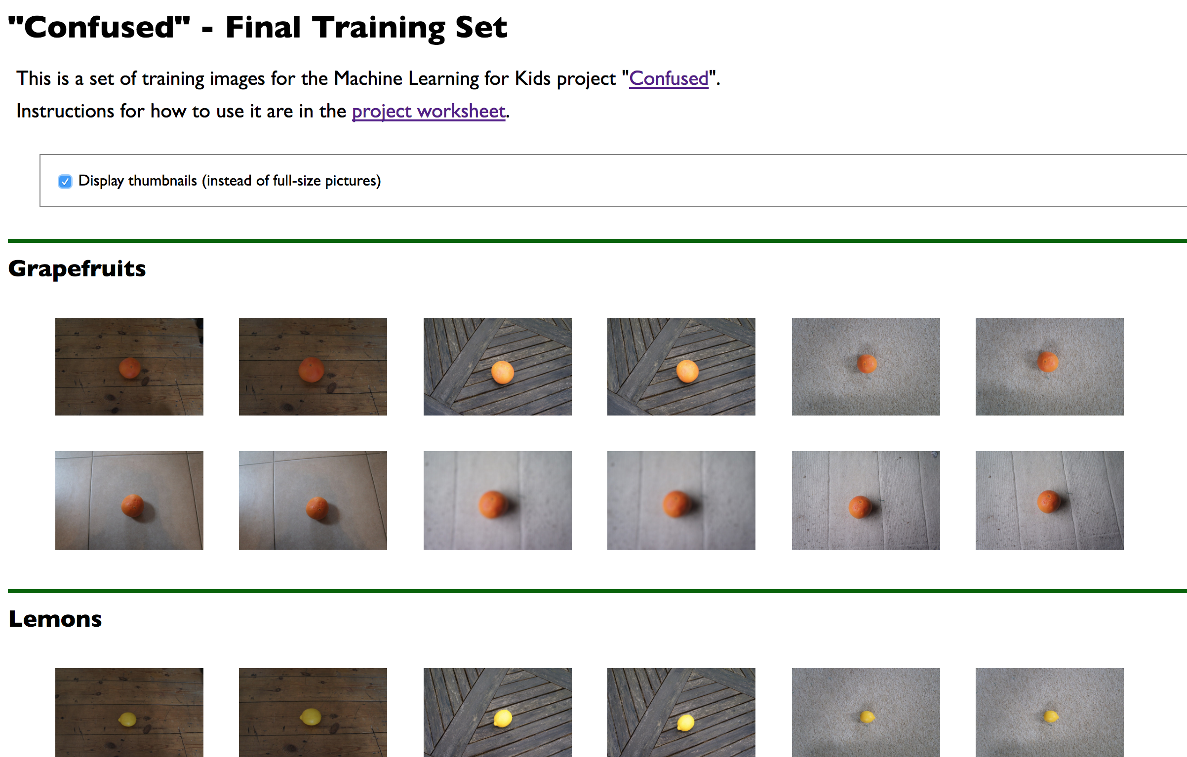

1. 如同前面的方式，將訓練用的照片拖曳至“lemon” 和“grapefruit”方框中

Drag the new training images into your “lemon” and “grapefruit” buckets, like you did before.   
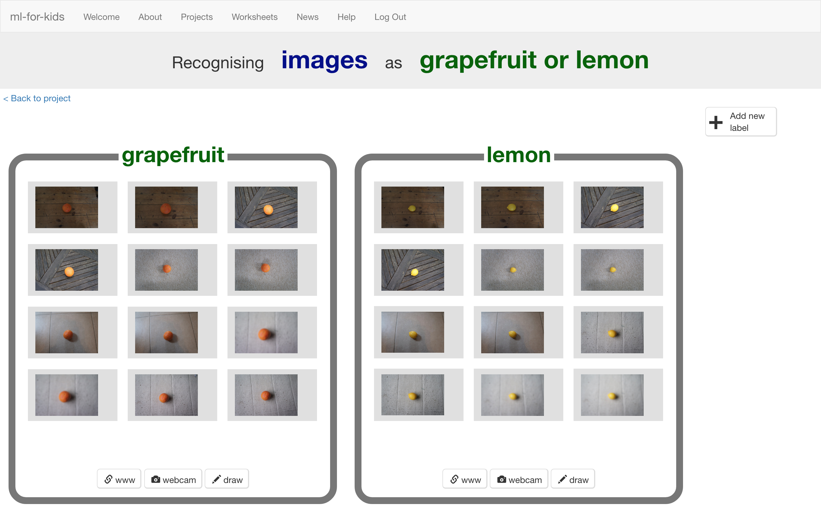

1. 點選“**< Back to project**”

Click the “**< Back to project**” link

1. 點選“**Learn & Test**”按鈕

Click the “**Learn & Test**” button

1. 點選“**Train new machine learning model**”，並等待訓練完成

Click the “**Train new machine learning model**” button, and wait for the model to finish training.

1. 回到Scratch

*如果你不小心關掉scratch，請做以下步驟：點選“****< Back to project****” -> 點選“****Make****” ->點選“****Scratch****” ->點選“****Open in Scratch”*** *-> 點選“****File****”-> 點選“****Load Project****”，選擇先前儲存的專案*

Switch back to the Scratch window.   
*If you accidentally closed it, you can get back to it by doing this:  
* Click the “****< Back to project****” link  
* Click the “****Make****” button  
* Click the “****Scratch****” button  
* Click the “****Open in Scratch****” button  
* Open the Scratch project you saved before, with “****File****” -> “****Load Project****”*

1. 重新執行專案

*點擊全螢幕，再點選綠旗執行。*

*這次電腦判別正確了嗎？*

Run the scripts again with the new model  
*Click full-screen, then click the Green Flag. Does it get it right this time?*

**你完成了什麼？**

**What have you done?**

機器學習模型會從你給的訓練資料中尋找共通的模式

Machine learning models learn to recognise patterns in what you use to train it.

如果訓練的照片都有一樣的背景，或者一樣的明亮度，或是一樣的清晰度，那麼這些都可能成為模型拿來辨識照片的基準

If all photos in a set have the same background, or the same lighting, or the same focus level – then those can be patterns that the model uses to recognise pictures.

這次，你使用了差異度更高的照片來訓練模型

This time, you used a wider variety of photos to train the model.

舉例來說，『檸檬』的訓練照片背景都不相同、有室內和室外拍攝、燈光有亮有暗、有些清晰有些模糊。他們唯一的共通點是都有一顆檸檬

For example, the “lemon” training photos were taken on different backgrounds, taken inside and outside, in light and dark, some in focus and some blurry. The only thing they all had in common was that they all had a lemon in there.

這表示電腦更可能注意到所有照片的共通處是照片的中央都有一顆黃色水果。

This meant it was much more likely that the pattern the computer spotted in the training photos was that there was a yellow fruit in the middle.

訓練照片的差異度在訓練一個可靠的模型中扮演著很重要的角色

Variety in training data is essential when training a reliable model.

**The “Russian Tank” problem**

此學習單靈感來自於一個古老的故事：The Russian Tank problem

This worksheet is based on an old story told to Artificial Intelligence students called “The Russian Tank problem”.

我們不清楚這是不是一個真實故事，因為他有很多版本。但不管真假，這個故事在機器學習訓練的教學中都是很好用的例子

It’s unclear whether or not it’s a true story, as there are many different versions. Whether or not it’s true, it’s a useful way to teach an important lesson in training machine learning systems.

以下是其中的兩個版本：

Here are two examples of how the story is told:

**找出偽裝的俄羅斯坦克**

**Spotting camouflaged Russian tanks**

很久以前，美軍決定利用機器學習來辨識出那些在森林中，躲在樹後方的坦克車。研究員使用沒有坦克躲在其內的森林照片，以及同樣的森林，但有坦克從樹後方伸出的照片來訓練模型。

Once upon a time, the US Army decided to use machine learning to recognize tanks hiding behind trees in the woods. Researchers trained a machine learning model using photos of a woods without tanks, and photos of the same woods with tanks sticking out from behind trees.

這方式看起來可行，但實際測試結果，模型的辨識結果跟瞎猜差不多

It seemed to work, but in tests the model didn’t do better than random guesses.

結果發現這些訓練照片中，有坦克車的照片都是在陰天拍的，而沒有坦克車的照片都是在晴天拍的。因此模型是利用晴天或陰天，而不是坦克車來當作辨識的基準。

It turned out that in the researchers' training data set, photos of camouflaged tanks had been taken on cloudy days, while photos of plain forest had been taken on sunny days. The machine learning model had learned to recognise cloudy days from sunny days, instead of recognising camouflaged tanks.

**分辨美國與俄羅斯坦克**

**Recognising American and Russian tanks**

很久以前，美軍試著訓練電腦從外形辨識出美軍坦克與俄羅斯坦克的差異，研究員使用他們所拍攝的美軍坦克，以及偷拍的俄羅斯坦克車照片來訓練模型。

Once upon a time, the US Army tried training a computer to tell the difference between Russian and American tanks by the way they look. Researchers trained a machine learning model using photos they took of American tanks, and spy photos they collected of Russian tanks.

但實際測試結果，模型的辨識結果跟瞎猜差不多

But when they tested it in the field, the machine learning model didn’t do any better than randomly guessing.

結果發現這些訓練照片中，美軍坦克的照片都是很大、高解析且高品質的，而遠距拍攝出的俄羅斯照片都是模糊、低解析度的。

It turned out that the researchers had photos of American tanks which were large, high-resolution and high-quality. But the long-distance spy photos of Russian tanks they were able to get were all blurry, low-resolution and grainy.

因此模型學到的是辨別模糊與清晰照片的差別，而不是辨別美國與俄羅斯坦克的差異

The machine learning model had learned to recognise the difference between grainy photos and high-quality photos, instead of Russian or America.